

**JSC “Kazakh British Technical University”**

**Faculty of Information Technology**

**Microprocessor Control Systems**

**Laboratory Work #4**

**Prepared by: Maratuly Temirbolat**

**Almaty 2021**

1. **Theme of works:**

The theme of the work is to get closer to the Unity Pro program and realize the ‘gate working’.

1. **Task and solving in Unity Pro:**

The task for the current Laboratory work is to create the automatic doors that opens and closes just pressing the button and choosing the direction of the doors. To solve the exercises we created necessary parameters as button (EBOOL type) which starts the engine to work, close and open(both EBOOL) that show whether the doors are opened or not, copy_button(EBOOL) in order to use RE function of the front, det_closed as well as det_open (both EBOOL) which are our sensors which indicates the whether the door reached the final position from both sides, direction (EBOOL) where 0 is left and 1 is right direction and finally km_on_off (EBOOL) that is responsible for the motor (does it work or not). Each second (using the byte %s6) the door moves if the motor is on and direction is pointed. We move the door by the position attribute (INT type) increasing or decreasing its value.

1. **Table of the variables with data types:**

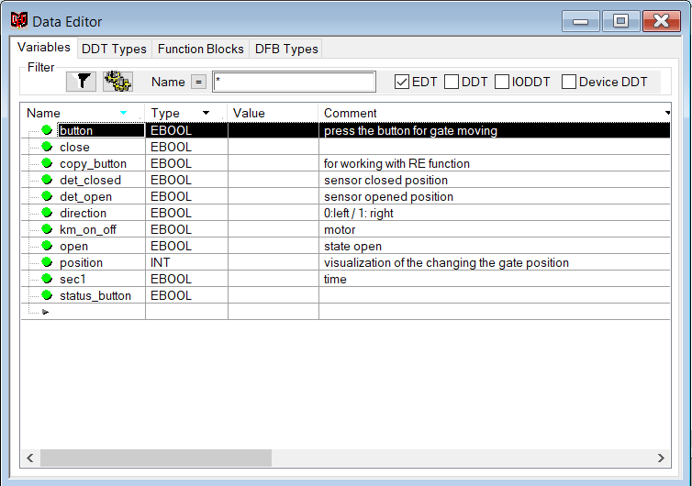

1. **Visualization of the program:**

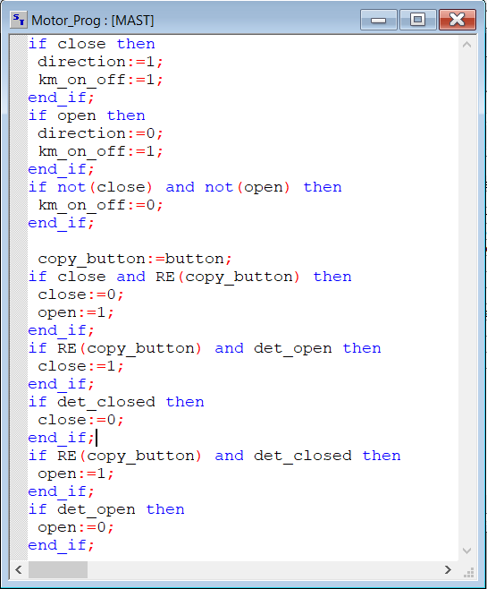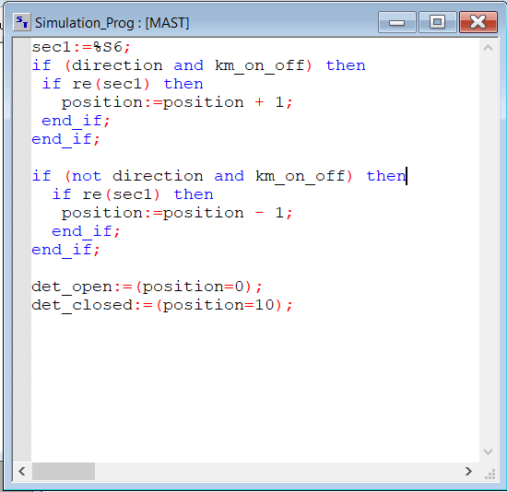

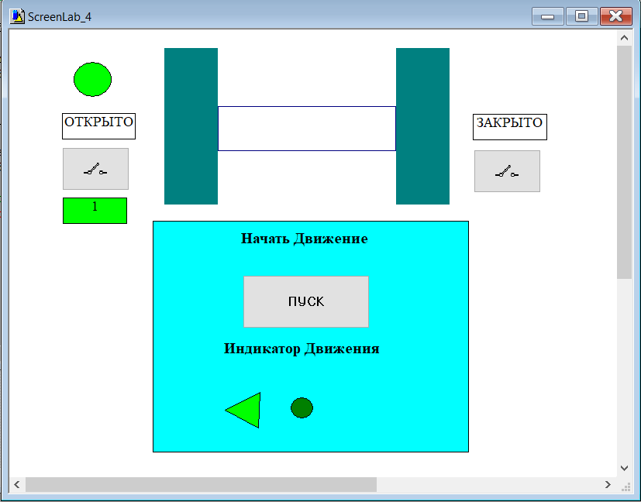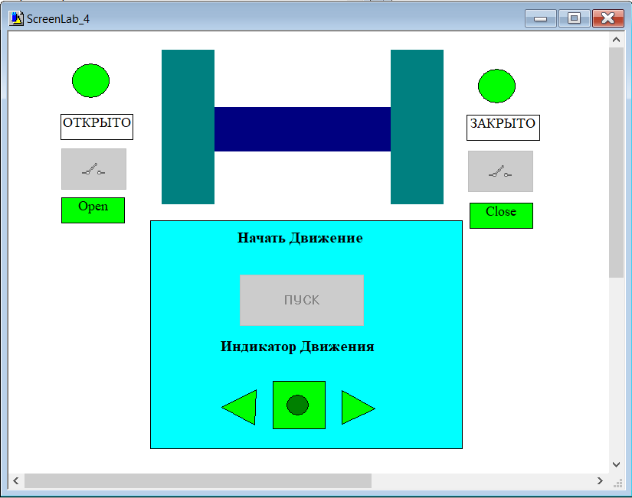

**🡪**

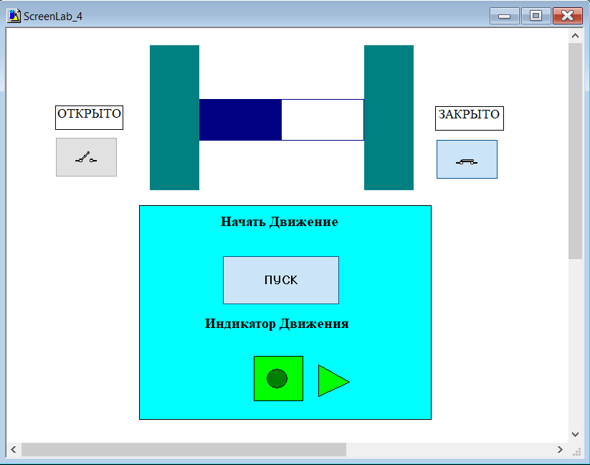

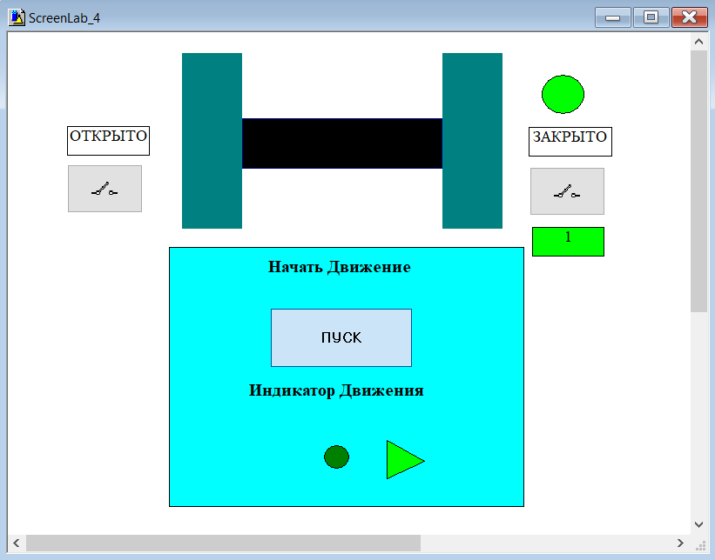

**🡪**

**Conclusion:**

During the Laboratory work we got acquainted with a more complex construction of coding for working on automatic doors. We used the rectangular, circles, buttons, text boxes in order to illustrate doors, walls, indicators, the appropriate information about the stages respectively. While the process there was also created remote control which begins the work of the engine and also shows whether it works or not as well as direction of the motion of the doors just lighting the needed triangle. The direction of the action is also reflected by the circles in left and right parts of the screen’s picture where the left upper circle demonstrates the motion to the left and right upper illustrates the right motion.